1: Download github from following site and install in machine <https://visualstudio.github.com/>

2:create git account

3: you can see git hub added to team explorer , connect to git hub (cat symbol)

4:go to file in menu of your solution🡪add to source control

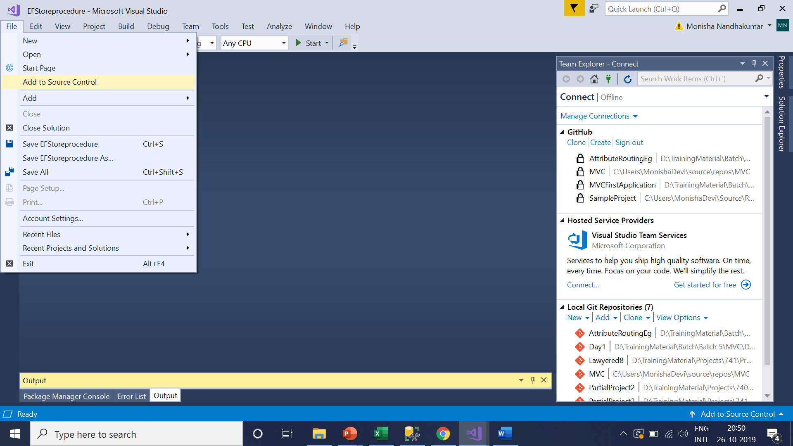

5:In Team explorer you can see your solution just added to git hub here my solution is EFStoreprocedure

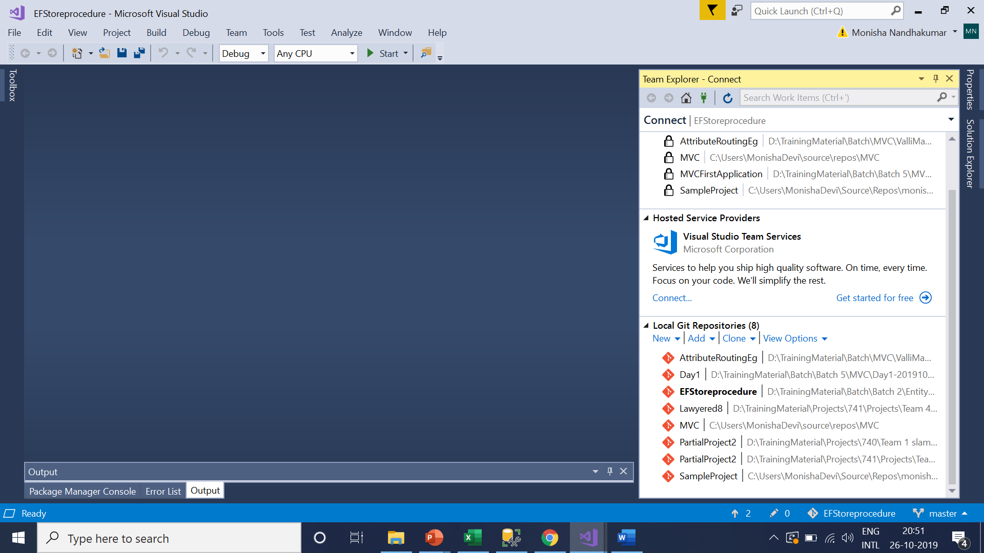

6.In Team explorer you can see clone option – copy made in local machine (clone it)

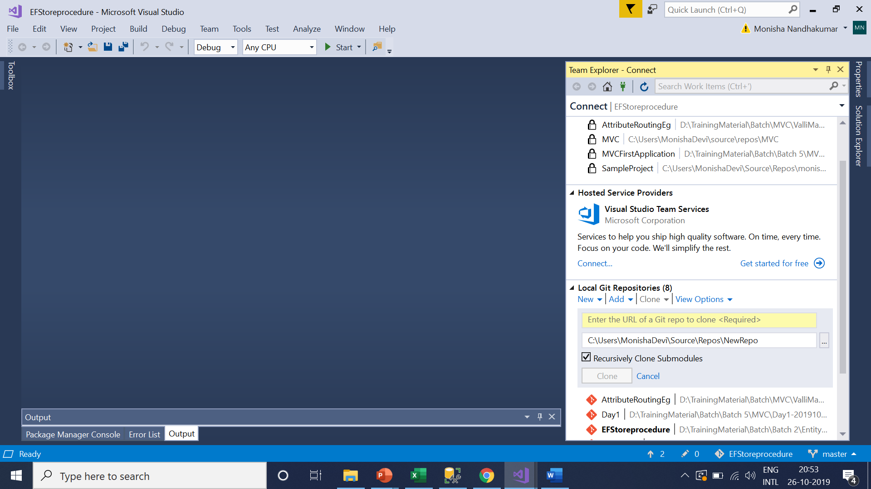

Enter you git access url in enter url column in team explorer when you try to clone only then clone button will be enabled

You will get this url : after sign up you can create a repository in git hub. At that point git hub will provide the url for your repository

If you are not able to create your url please use the below

Use this URL :https://github.com/monishanandhakumar/SampleProject.git



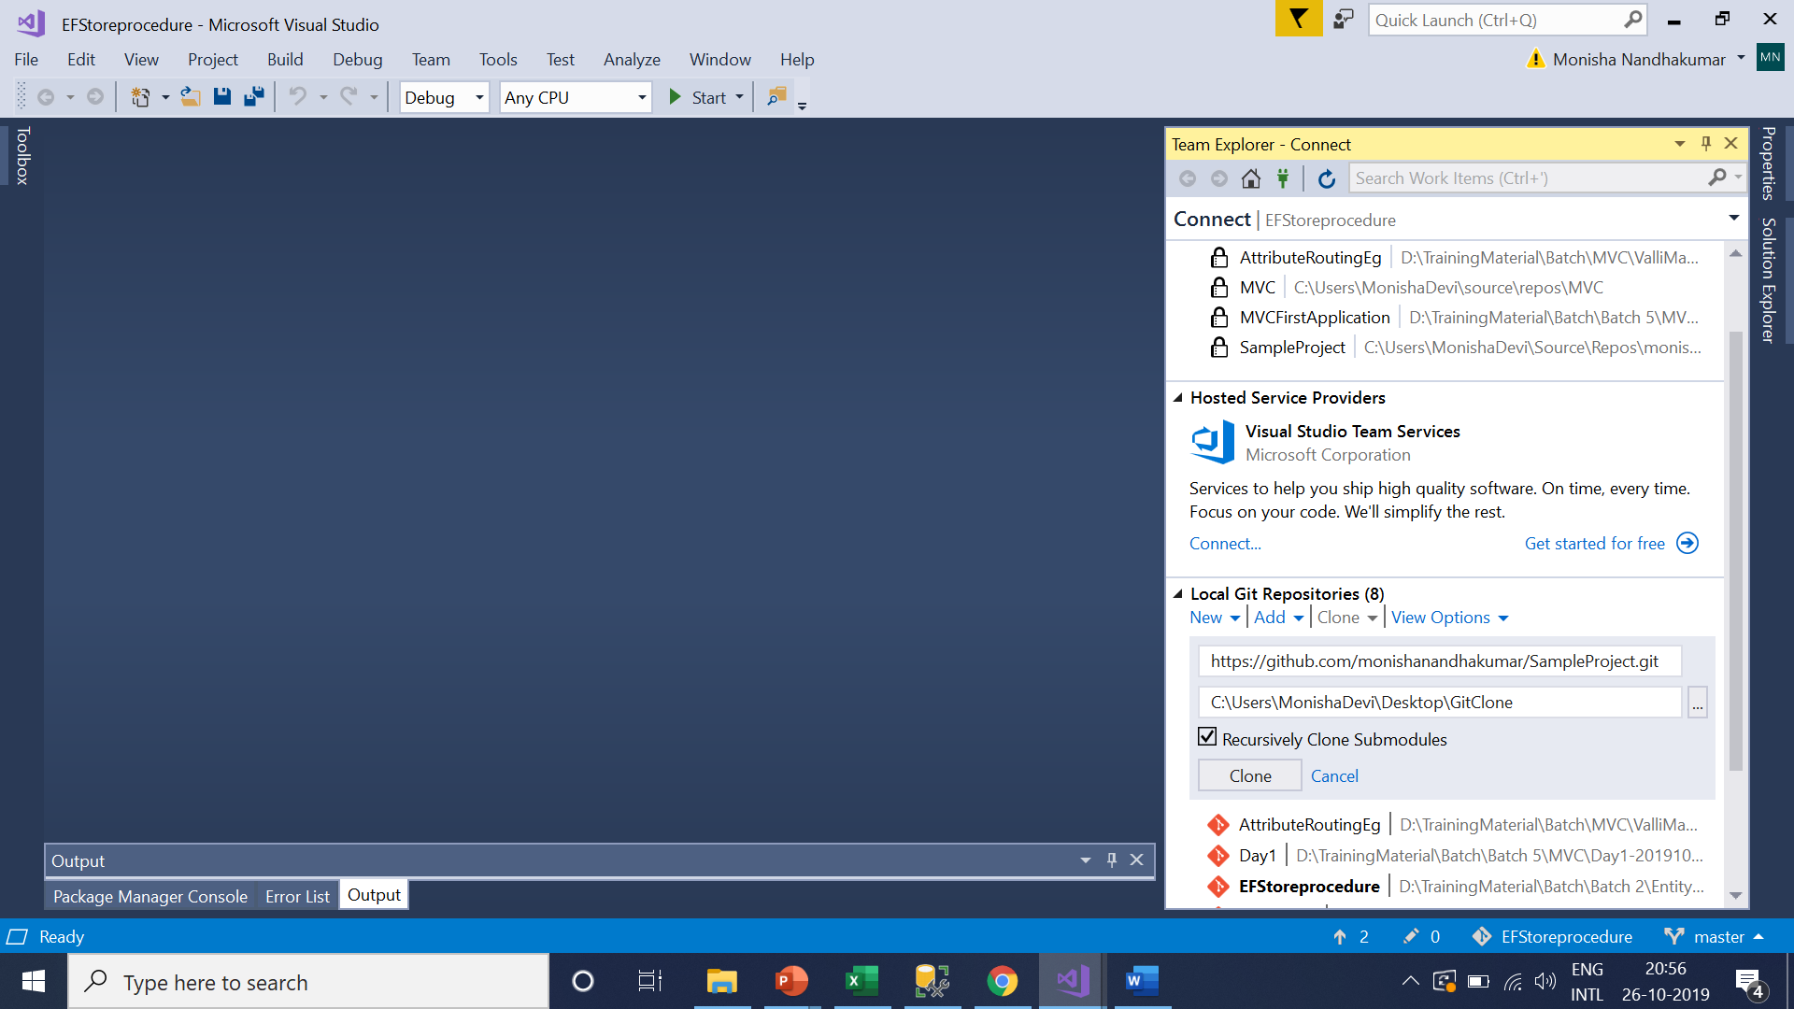

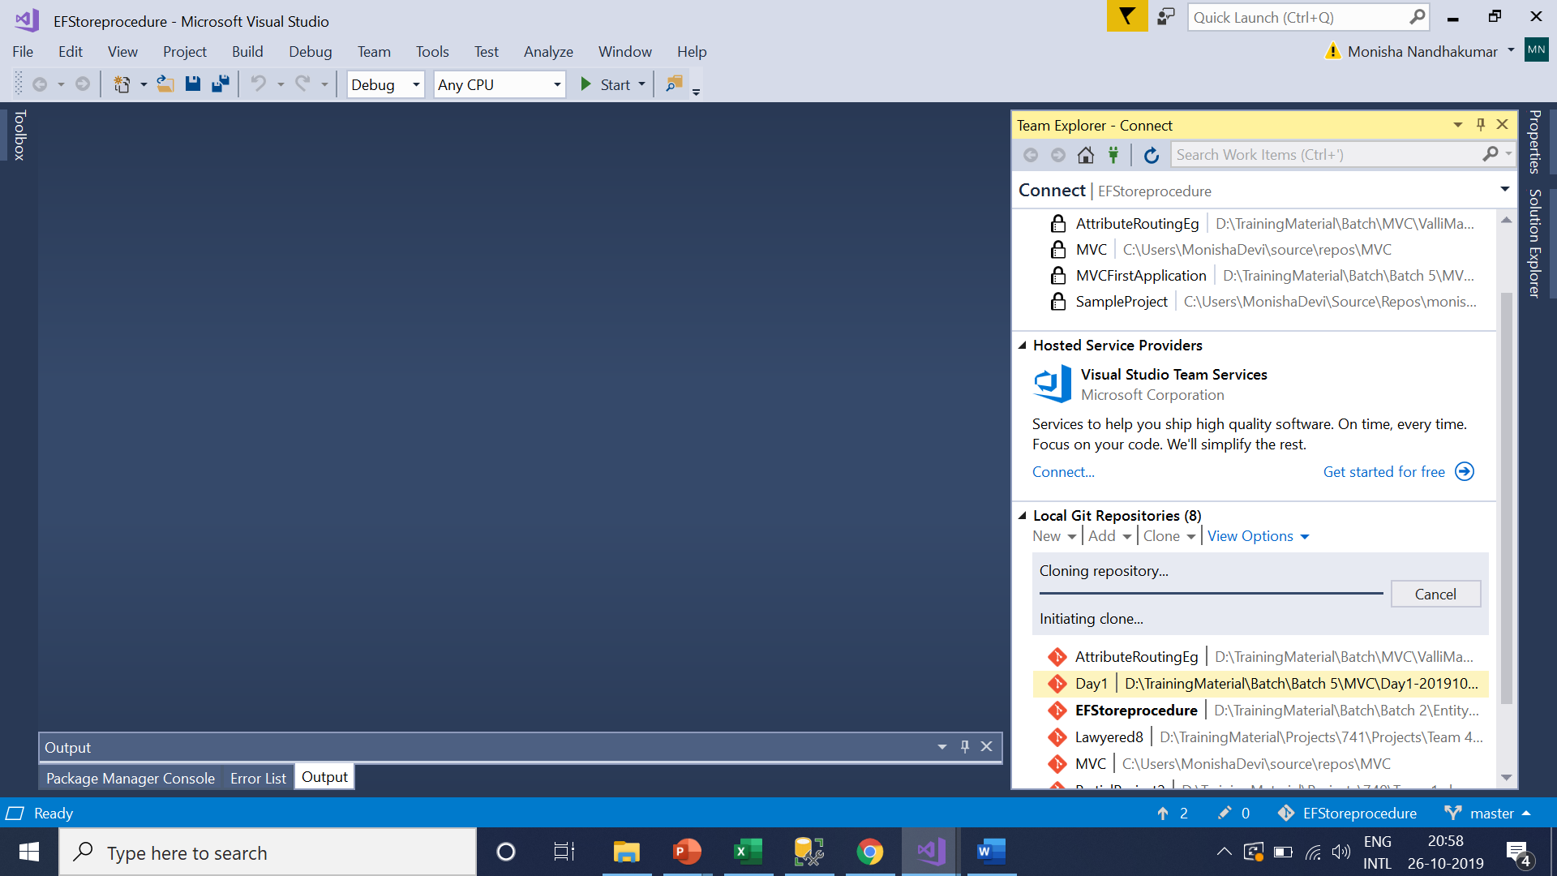

Go to home in team explorer🡪Click sync

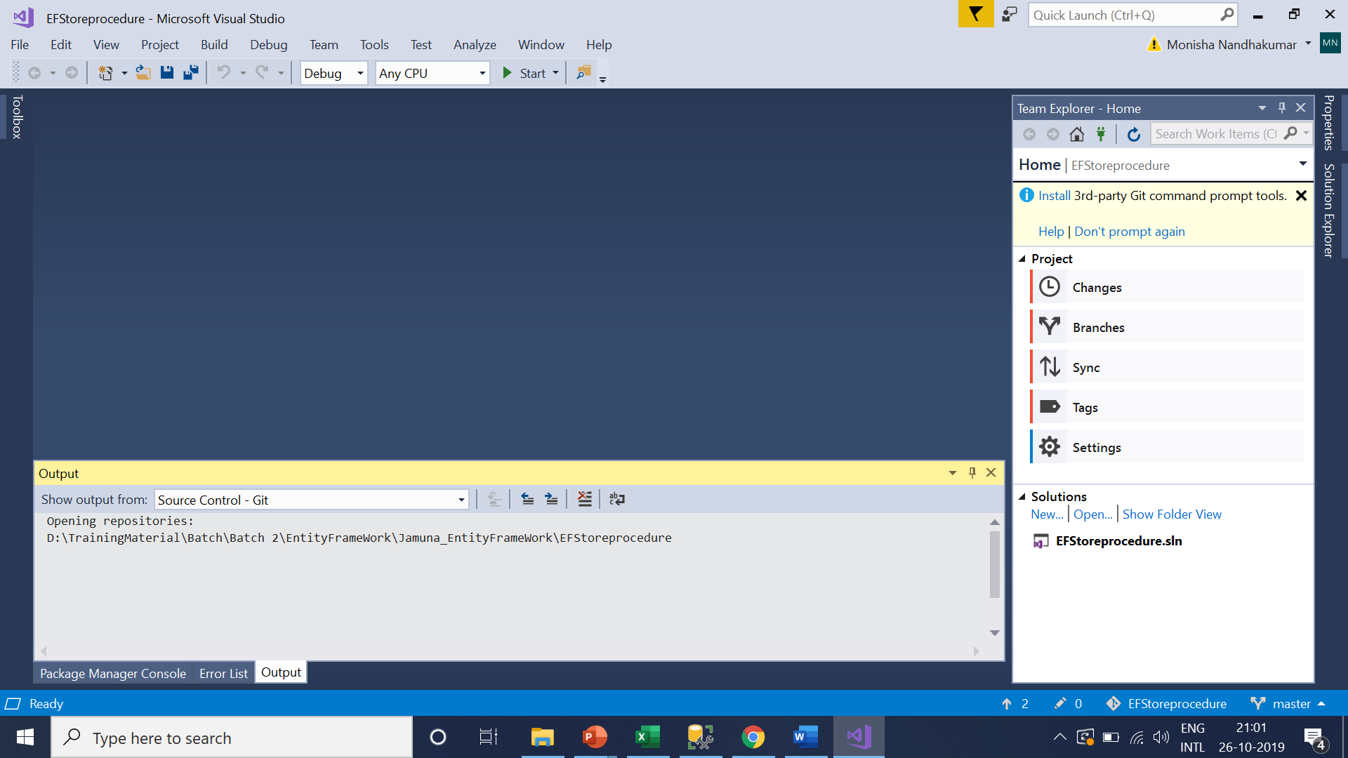

Click publish to github (cat symbol)

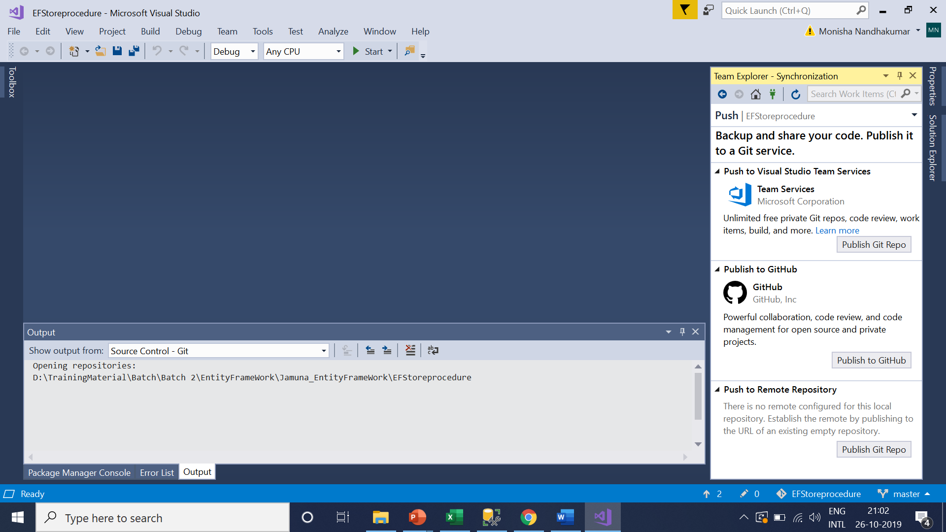

Enable private and click publish button

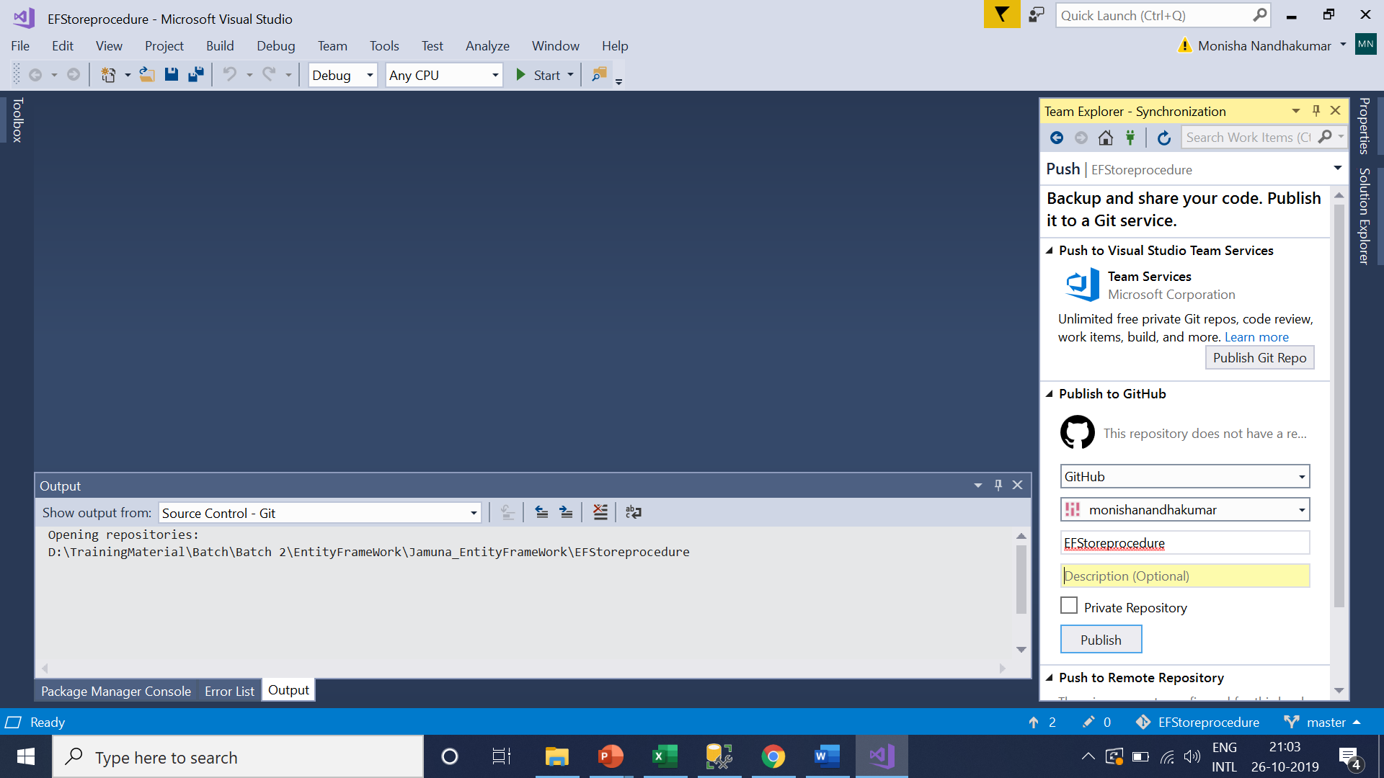

Repository created successfully and synchronization will takes places . this will take few minutes

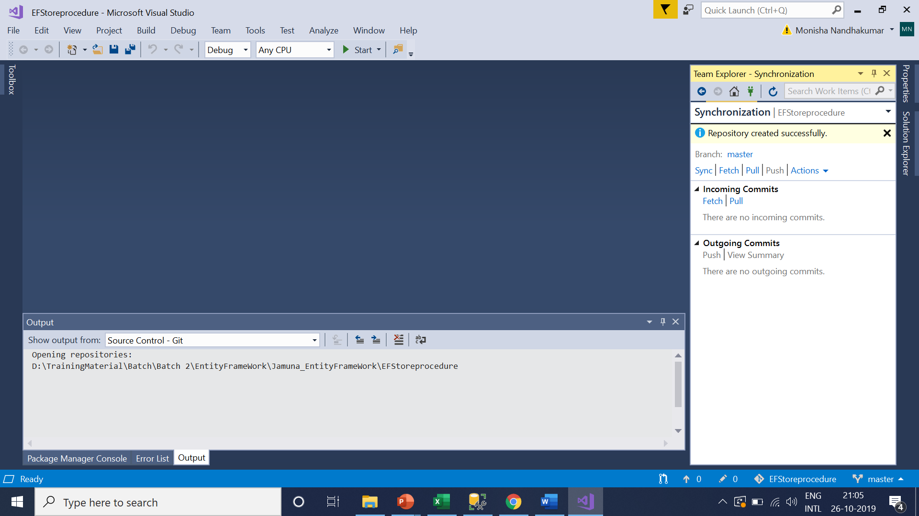

I can see EFStoreProcedure

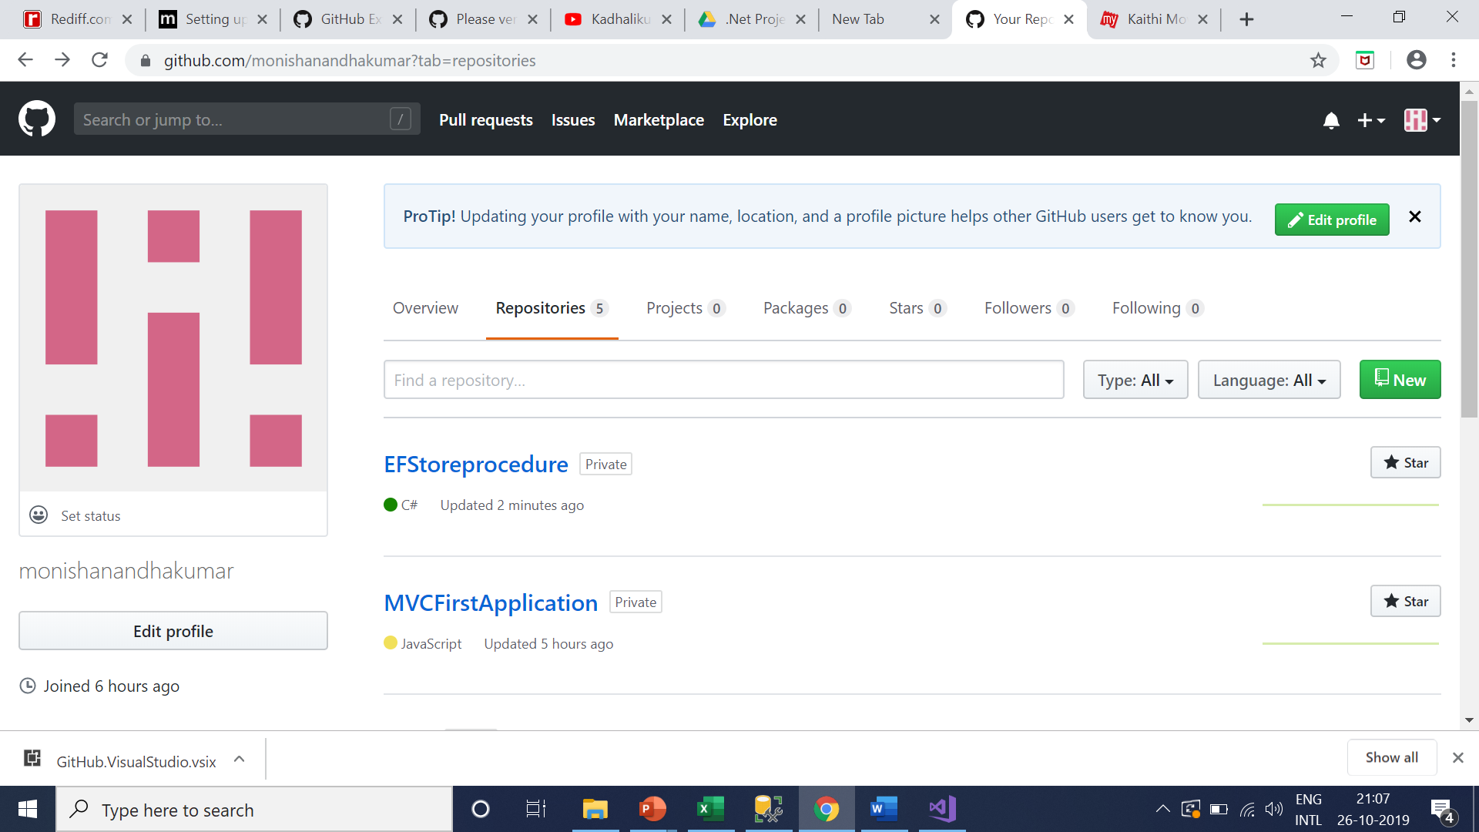

I can access any files in it

